**AIM:** Write a program to implement Linear Search using arrays

**SOURCE CODE:**

#include<stdio.h>

#include<stdlib.h>

#include<conio.h>

void main()

{

int a[5];

int l=0;

int u=4;

int i,found=0,key;

system("cls");

printf("\n Enter the numbers:");

for(i=0;i<5;i++)

{

scanf("%d",&a[i]);

}

printf("\n Enter the key numbers:");

scanf("%d",&key);

i=l;

while(i<=u)

{

if(a[i]==key)

{

found=1;

printf("\n Successful at location %d",i+1);

}

i++;

}

if(found==0)

{

printf("\n Search Unsuccessful");

}

getch();

}

**OUTPUT:**

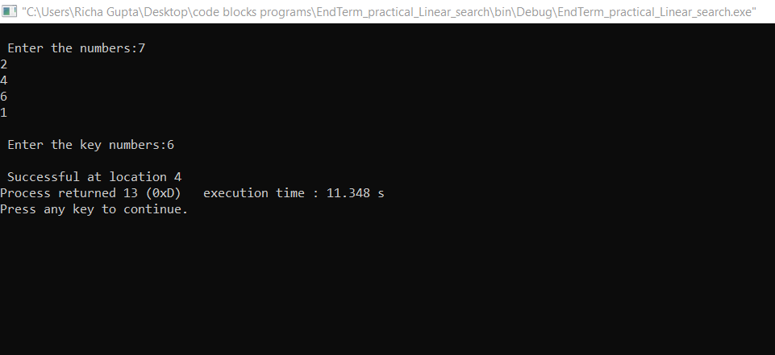

**AIM:** Write a program to implement Linear Search using Linked List

**SOURCE CODE:**

#include<stdio.h>

#include<conio.h>

struct node

{ int data;

struct node *link;

};

struct node *head,*n;

void insert()

{

int x;

struct node *ptr;

ptr=head;

printf("Enter the value of new node: ");

scanf("%d",&x);

n=(struct node *)malloc(sizeof(struct node));

n->data=x;

if(head==NULL)

{

n->link=NULL;

head=n;

}

else

{

while(ptr->link!=NULL)

{

ptr=ptr->link;

}

n->link=NULL;

ptr->link=n;

}

}

void traversal()

{

struct node *ptr;

ptr=head;

if(head==NULL)

{

printf("List is empty");

getch();

}

else

{

while(ptr!=NULL)

{

printf("%d-> ",ptr->data);

ptr=ptr->link;

}

getch();

}

}

void srch()

{

struct node *ptr;

ptr=head;

int c=0,key,i=0;

if(head==NULL)

{

printf("List is empty");

getch();

}

else

{

printf("Enter the value to search: ");

scanf("%d",&key);

while(ptr!=NULL||c==1)

{

if(ptr->data==key)

{

c=1;

break;

}

else

{

ptr=ptr->link;

i=i+1;

}

}

if(c==1)

{

printf("The value %d is found at position: %d",key,i+1);

getch();

}

if(c==0)

{ printf("Value not found");

getch();

}

}

}

void main()

{

int c;

L:system("cls");

printf("1. Insertion\n");

printf("2. Traversal\n");

printf("3. Search\n");

printf("4.Exit\n");

printf("Enter your choice: ");

scanf("%d",&c);

switch(c)

{

case 1: insert();

goto L;

case 2: traversal();

goto L;

case 3: srch();

goto L;

case 4: exit(0);

default: printf("Invalid choice...Enter your choice again");

getch();

goto L;

}

}

OUTPUT:

